Start of Block: Starting Block

Q4   
**Forecasting Red Tide Air Contamination:**   
**A Survey of Southern Florida Gulf Coast Residents**

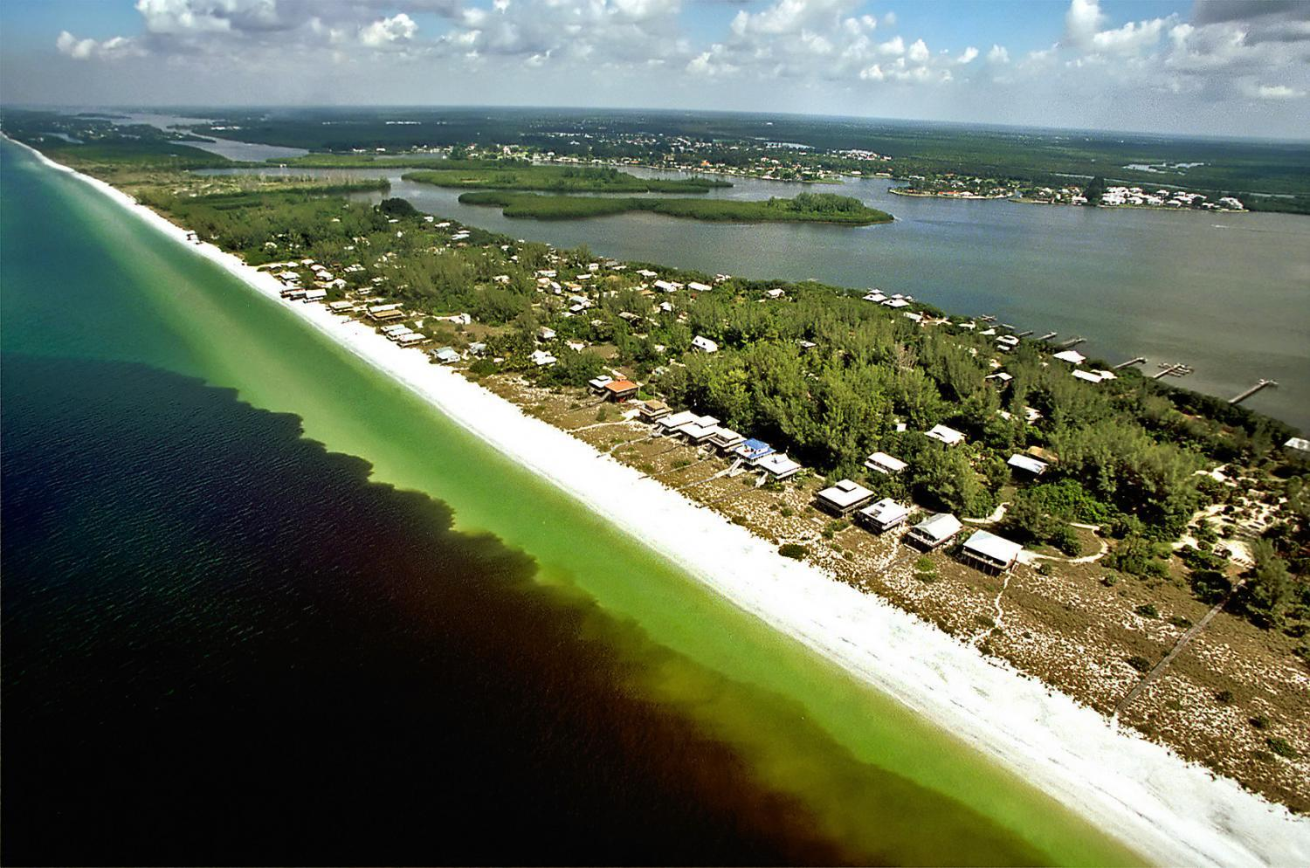  
 Red Tide Bloom off the Southern Florida Gulf Shore. Credit: P. Schmidt, Charlotte Sun   
    
*Conducted by Virginia Tech, in collaboration with Mote Marine Laboratory.  
 Supported by the Global Change Center and the Institute for Society, Culture, and Environment at Virginia Tech.*   
  
 Your answers will help public officials make decisions that reflect your preferences.  
 Thank you for your help with this important research effort.

|  |  |
| --- | --- |
| Page Break |  |

Q5 Survey Consent Form

Please read the following form carefully. It provides information about the research project and the tasks you will be asked to complete. You need to read and agree to this form to proceed to the actual survey.   
    
I. Research team ("Investigators"):  
   
 Klaus Moeltner, PhD, Virginia Tech                     [moeltner@vt.edu](mailto:moeltner@vt.edu) / 540-231-8249  
 Hosein Foroutan, PhD, Virginia Tech,                 [hosein@vt.edu](mailto:hosein@vt.edu) / 540-232-8400  
 Shane Ross, PhD, Virginia Tech                         [sdross@vt.edu](mailto:sdross@vt.edu) / 540-231-1616  
 David G. Schmale III, PhD, Virginia Tech           [dschmale@vt.edu](mailto:dschmale@vt.edu) / 540-231-6943            
   
 II. Purpose This research is a collaboration between Virginia Tech (VT) and Mote Marine Laboratory (Mote). We want to learn how Florida red tide blooms along the Southern Florida Gulf Coast (SFGC) have affected different aspects of local residents’ life. We are especially interested in how locals have coped with the airborne toxin produced by Florida red tide that causes coughing and other respiratory irritation along local beaches and, potentially further inland as well. Furthermore, we would like to learn how a better forecasting system informing locals of expected Florida red tide air quality conditions one day into the future for each square mile within the forecasting area may help residents better prepare for such events, and possibly lessen the negative impacts of poor air quality caused by Florida red tide.   We invite you to participate in this online survey. All survey participants will be year-round residents of the SFGC, specifically Manatee, Sarasota, Charlotte, Lee, and Collier counties, and at least 18 years of age.   The survey will ask you to consider different forecasting systems for your area and vote for the one you prefer. This will help researchers and public officials understand the type of forecast you would support or oppose in an actual public vote.   
   
 Your participation is entirely voluntary.  
   
 III. Procedures  
 The survey will ask how Florida red tide air quality issues have affected your daily life in recent years. It will also inform you on the red tide air quality information systems that are already in place. The survey will then introduce different versions of the proposed 24-hour forecasting system, and ask you which version you would prefer. We will also be asking some basic demographic questions. The survey takes about 20-30 minutes to complete.  
   IV. Risks  
 The survey tasks require a high level of concentration, so you might experience some degree of fatigue, depending how long you decide to stay online for a given session. You can take as many breaks from the survey as needed.   
   
 V. Benefits  
 No promise or guarantee of benefits by VT or Mote has been made to encourage you to participate. However, your participation will benefit resource managers and officials by better understanding the value to local residents of different versions of the forecasting system. Thus, the survey will provide guidance as to the optimal level of investment for potential implementation of such a system in the future.  
   
 VI. Extent of Anonymity and Confidentiality Your identity will remain completely anonymous to the research team. Survey results will be shared with the public via conference presentations, reports, and publications only in aggregated and summarized fashion, without revealing the identity of individual participants. Anonymous data from this survey will be kept indefinitely in a secured location and will only be directly accessible to research team members at Virginia Tech and Mote Marine. Partial data may be shared with other researchers beyond the research team for purposes of validation and replication. However, your responses will always remain completely anonymous. The Virginia Tech (VT) Institutional Review Board (IRB) may view the study’s data for auditing purposes. The IRB is responsible for the oversight of the protection of human subjects involved in research.  
   
 VII. Compensation  
 Other than through your arrangement with Qualtrics, the firm that has contacted you and is implementing this survey under contract with Virginia Tech, there will be no additional compensation for your participation.  
   
 VIII. Freedom to Withdraw  
 It is important for you to know that you are free to withdraw from this survey at any time without penalty. You are free not to answer any questions that you are not comfortable responding to without penalty.   
   
 IX. Questions or Concerns  
 Should you have any questions about this study, you may contact one of the research investigators whose contact information is included at the beginning of this document.  
   
 Should you have any questions or concerns about the study’s conduct or your rights as a research subject, or need to report a research-related injury or event, you may contact the Virginia Tech Institutional Review Board at irb@vt.edu or (540) 231-3732.  
   
 Your Permission  
 "By clicking the 'I agree' button below, I confirm that I am at least 18 years of age, I have read and understood this form, and agree to participate in all parts of the study as described in the form. I also understand and accept that my personal information (name, e-mail address) will remain unknown (anonymous) to the research team."  
   
 ​You must click the 'I agree' button to proceed to the actual survey. If you do NOT agree please click the 'opt out' button and close your browser window.

|  |
| --- |
|  |

Q6 Your choice:

* **I agree** (1)
* **I opt out** (2)

Skip To: End of Block If Your choice: = <strong>I opt out</strong>

|  |  |
| --- | --- |
| Page Break |  |

Q7   
**Background information**  
     
Florida red tide (RT) is caused by a microscopic organism ("*Karenia brevis*") that is always present in the Gulf of Mexico in small amounts. However, at times widespread "blooms" can occur with large numbers of these micro-organisms present in near-shore waters.   
   
 These blooms release a **poisonous substance ("toxins")** that can kill fish and other marine animals.  Importantly for this survey, when these toxins become airborne, they can have **adverse respiratory effects** on people that inhale this contaminated air. Toxins can get into the air due to wave action and wind blowing over the water surface.  
   
 Symptoms to humans caused by these toxins can include coughing, sneezing, teary or burning eyes, and itchy or burning throat. They can last for an extended period especially for individuals with pre-existing respiratory conditions such as asthma. The risk of exposure to these toxins and their impact on humans is higher when winds blow onshore.   
    
Note that RT air toxins are odorless (have no smell) and invisible to the human eye. You may smell dead fish nearby, but you can't smell the actual toxins.

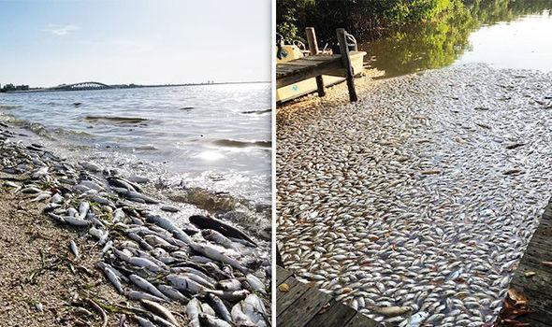  
 Red tide fish kill / Image: Danielle Goetz•Hooked on SUP

|  |  |
| --- | --- |
| Page Break |  |

Q8

While RT blooms along the Southern Florida Gulf Coast (SFGC) have occurred periodically throughout history, some especially intense and widespread blooms have been witnessed in recent years. Also, as the population of the SFGC grows, more and more people can be affected by Florida red tide.  
   
 In 2017/2018 the SFGC experienced one of the worst and longest RT episode in decades, at times stretching over 150 miles of coast line, and producing extremely high RT concentrations. Thousands of fish, birds, turtles, and marine mammals were killed by the bloom and washed onto local beaches and into local canals.  
   
 For example, the image below shows a map of RT cell concentrations found in water samples along the coast throughout August, 2018.  
 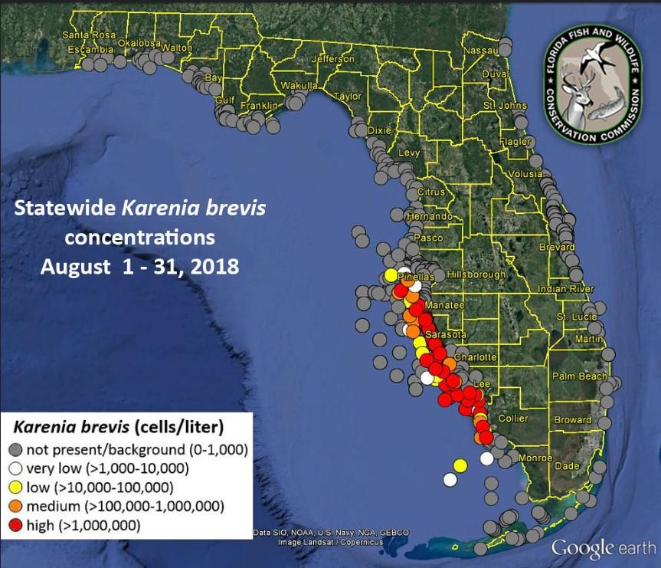  
 High RT concentrations along the Southern Gulf Coast in August, 2018 /Source: FL Fish & Wildlife Conservation Commission

|  |  |
| --- | --- |
| Page Break |  |

Q9

Since then, other prolonged blooms have occurred along the SFGC, for example in late fall of 2019.  
   
 In general, RT blooms can happen at any time during the year, but in recent years they have been especially frequent and intense during the months of September through January.  
   
 During intensive RT blooms not only do marine animals face danger, but local residents along with the wider local economy also suffer. Many restaurants and other tourism-related businesses lose customers, beach visits and other forms of outdoor recreation become unpleasant or dangerous to human health, and the clean-up costs of beaches and local canals can strain community budgets.  
 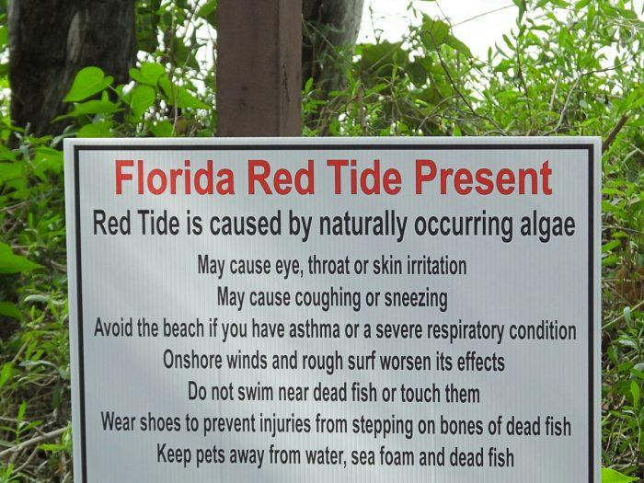  
 Warning sign at a local beach. Source: Civil Eats web site / Nano Riley.  
   
 In the following section, we will ask you about your experience with RT, and how it may have affected your household's daily life and activities.  
   
Q10   
**Your household's outdoor activities**   
  
 There are many ways residents of the SFGC can enjoy outdoor activities along the coast. How about you and your family that lives with you ("household")?

Q11. Over the **last 12 months**, have **any of your household members** participated in the following outdoor activities within the SFGC area (Manatee, Sarasota, Charlotte, Lee, or Collier county)?  (please check all that apply)?

|  |  |  |  |
| --- | --- | --- | --- |
|  | yes (1) | no (2) | not sure (3) |
| **beach activities** (walking, jogging, beachcombing, sun bathing, beach games, bird watching, photography, etc.) (1) |  |  |  |
| **water activities** (swimming or wading, water games, snorkeling, scuba diving) (2) |  |  |  |
| **non-motorized watersports** (kayaking, stand-up paddle board, surfing, sailing, etc.) (3) |  |  |  |
| **motorized watersports** (boating, jet-skiing, etc.) (4) |  |  |  |
| **fishing /  clam digging / shellfish harvesting**  (from boat or shore) (5) |  |  |  |
| **organized outdoor sports** as **player or spectator** (tennis, golf, pickle-ball, baseball, soccer, etc. - NOT including school sports) (6) |  |  |  |
| **school-related activities** as **player/participant or spectator** (sports, field days, ceremonies, special events) (7) |  |  |  |
| **trail / road activities**: jogging, walking, biking, skating, dog walking, etc. (8) |  |  |  |
| **park / picnic shelter activities**: lunch, barbecue, family gatherings, picnics, relaxing, lawn games, etc.) (9) |  |  |  |
| **special outdoor events** as **participant or spectator** (concerts, fairs, exhibitions, art shows, farmers markets, etc.) (10) |  |  |  |
| **professional or volunteer outdoor activities** (construction, landscaping, life guard, beach patrol, clean-up, turtle nest surveillance, etc.) (11) |  |  |  |
| **other** (pl. specify) (12) |  |  |  |

|  |  |
| --- | --- |
| Page Break |  |

Q12

In a typical week (Monday through Sunday) WITHOUT any RT problems, how many hours does your household spend on the following outdoor activities within the SFGC area (Manatee, Sarasota, Charlotte, Lee, or Collier county)? Please check all that apply.  
   
(Please add up all hours by all family members. For examples, if 2 members of your household each go jogging for 1 hour twice a week, the total hours would be 2x2 = 4. Add a check under the "1-4 hour" column.)

|  |  |  |  |  |  |
| --- | --- | --- | --- | --- | --- |
|  | zero hours / week (1) | 1-4 hours / week (2) | 5-8 hours / week (3) | 9-12 hours / week (4) | more than 12 hours / week (5) |
| **beach activities** (walking, jogging, beachcombing, sun bathing, beach games, bird watching, photography, etc.) (1) |  |  |  |  |  |
| **water activities** (swimming or wading, water games, snorkeling, scuba diving) (2) |  |  |  |  |  |
| **non-motorized watersports** (kayaking, stand-up paddle board, surfing, sailing, etc.) (3) |  |  |  |  |  |
| **motorized watersports** (boating, jet-skiing, etc.) (4) |  |  |  |  |  |
| **fishing /  clam digging / shellfish harvesting**  (from boat or shore) (5) |  |  |  |  |  |
| **organized outdoor sports** as **player or spectator** (tennis, golf, pickle-ball, baseball, soccer, etc. - NOT including school sports) (6) |  |  |  |  |  |
| **school-related activities** as **player/participant or spectator** (sports, field days, ceremonies, special events) (7) |  |  |  |  |  |
| **trail / road activities**: jogging, walking, biking, skating, dog walking, etc. (8) |  |  |  |  |  |
| **park / picnic shelter activities**: lunch, barbecue, family gatherings, picnics, relaxing, lawn games, etc.) (9) |  |  |  |  |  |
| **special outdoor events** as **participant or spectator** (concerts, fairs, exhibitions, art shows, farmers markets, etc.) (10) |  |  |  |  |  |
| **professional or volunteer outdoor activities** (construction, landscaping, life guard, beach patrol, clean-up, turtle nest surveillance, etc.) (11) |  |  |  |  |  |
| **other** (pl. specify (12) |  |  |  |  |  |

|  |  |
| --- | --- |
| Page Break |  |

Q13

In a **typical week** (Monday through Sunday) **WITHOUT any RT problems**, how many hours does your household spend outside on a **balcony, deck, terrace, or private yard / garden of your residence**?   
    
*(Please add up all hours by all family members. For examples, if there are 4 people in your household, and all of them eat dinner outside for 1 hour, 5 days / week, the total would be 20 hours. Check the "12-24 hours" column.)*

|  |  |  |  |  |  |  |
| --- | --- | --- | --- | --- | --- | --- |
|  | zero hours / week (1) | 1-4 hours / week (2) | 5-8 hours / week (3) | 9-12 hours / week (4) | 12-24 hours / week (5) | more than 24 hours / week (6) |
| outside time around your home / residence (balcony, deck, terrace, yard, etc.) (1) |  |  |  |  |  |  |

|  |  |
| --- | --- |
| Page Break |  |

Q14   
**How has poor air quality related to Florida red tide affected you and your family?**   
  
 You may have experienced episodes of RT blooms during the time you've lived in the SFGC area. We are curious to learn how these blooms have impacted your daily life and activities.

|  |
| --- |
|  |

Q15 During the time you have lived in the SFGC area (Manatee, Sarasota, Charlotte, Lee, or Collier county), how has **Florida** **red tide air contamination** affected yourhousehold's**outdoor activities** in the SFGC area(other than at your personal residence)?   
    
(Please check all that apply, if ANY of your household members were affected)

|  |  |  |  |  |  |  |
| --- | --- | --- | --- | --- | --- | --- |
|  | never (1) | sometimes (2) | often (3) | almost every day during bloom (4) | can't remember (5) | not applicable - we never participated in such activities (6) |
| had to **cancel or postpone** activities on a given day (1) |  |  |  |  |  |  |
| had to **shorten** activities on a given day (2) |  |  |  |  |  |  |
| had to **re-locate** activities on a given day (3) |  |  |  |  |  |  |

|  |  |
| --- | --- |
| Page Break |  |

|  |
| --- |
|  |

Q16 During the time you have lived in the SFGC area (Manatee, Sarasota, Charlotte, Lee, or Collier county), how has **Florida** **red tide air contamination** affected yourhousehold's time spent outside on a **balcony, deck, terrace, or private yard / garden of your residence**?   
    
(Please check all that apply, if ANY of your household members were affected)

|  |  |  |  |  |  |  |
| --- | --- | --- | --- | --- | --- | --- |
|  | never (1) | sometimes (2) | often (3) | almost every day during bloom (4) | can't remember (5) | not applicable - we never participated in these activities (6) |
| had to **cancel or postpone** activities on a given day (1) |  |  |  |  |  |  |
| had to **shorten** activities on a given day (2) |  |  |  |  |  |  |

|  |  |
| --- | --- |
| Page Break |  |

|  |
| --- |
|  |

Q17 During the time you have lived in the SFGC area (Manatee, Sarasota, Charlotte, Lee, or Collier county), how has **Florida** **red tide air contamination** affected yourhousehold in any of the following **additional ways**?   
    
(Please check all that apply, if ANY of your household members were affected)

|  |  |  |  |  |  |  |
| --- | --- | --- | --- | --- | --- | --- |
|  | never (1) | sometimes (2) | often (3) | almost every day during bloom (4) | can't remember (5) | not applicable (6) |
| out-of-town family or friends **cancelled visits** (1) |  |  |  |  |  |  |
| could not **open windows** **or doors** at home or roll down windows in car (2) |  |  |  |  |  |  |
| could not **let pets out** into the yard / garden (3) |  |  |  |  |  |  |
| **RT toxins entered home or car** through the air conditioning system (4) |  |  |  |  |  |  |

|  |  |
| --- | --- |
| Page Break |  |

|  |
| --- |
|  |

Q18 During the time you have lived in the SFGC area (Manatee, Sarasota, Charlotte, Lee, or Collier county), how has **Florida** **red tide air contamination** affected yourhousehold's **personal health**?   
    
(Please check all that apply, if ANY of your household members were affected)

|  |  |  |  |  |  |  |
| --- | --- | --- | --- | --- | --- | --- |
|  | never (1) | sometimes (2) | often (3) | almost every day during bloom (4) | can't remember (5) | not applicable (6) |
| experienced **irritation**, but did NOT have to see doctor or go to hospital (1) |  |  |  |  |  |  |
| experienced severe irritation - had to **see doctor or go to hospital** (2) |  |  |  |  |  |  |
| bothered by / did get sick from **smell of dead fish** (3) |  |  |  |  |  |  |

|  |  |
| --- | --- |
| Page Break |  |

|  |
| --- |
|  |

Q19 During the time you have lived in the SCGC area (Manatee, Sarasota, Charlotte, Lee, or Collier county), did **Florida** **red tide air contamination** cause your household to **take any of the following actions**?   
    
(Please check all that apply, if ANY of your household members were affected)

|  |  |  |  |  |
| --- | --- | --- | --- | --- |
|  | yes (1) | no (2) | can't remember (3) | not applicable (4) |
| **moved further away from shore** (but stayed within area) (1) |  |  |  |  |
| **sold boat** or other **water sports equipment** (2) |  |  |  |  |
| **put house / condo on the market** - will leave area in near future (3) |  |  |  |  |
| **changed job / profession** or **retired early** to avoid time outdoors (4) |  |  |  |  |

|  |  |
| --- | --- |
| Page Break |  |

Q20   
Florida red tide air quality information today   
  
 In this section we will remind you of the **three primary public sources** that are available today to inform you about RT air quality conditions.  They are:   
    
  **Beach Conditions Reporting System** (provided by Mote Marine Laboratory) **Red Tide Current Status web site** (provided by the Florida Fish & Wildlife Conservation Commission) **Gulf of Mexico Harmful Algal Bloom Forecast** (provided by the National Oceanic and Atmospheric Administration)   
  
     
Here are some details on each of these three sources:

|  |  |
| --- | --- |
| Page Break |  |

Q21   
Mote Marine Laboratory & Aquarium's Beach Conditions Reporting System (BCRS)   
  
 Mote Marine Laboratory & Aquarium (Mote) in Sarasota, FL, manages the BCRS web site, which can be accessed at <https://visitbeaches.org/>.   
  
 It provides **twice-daily updates on current beach conditions** at 37 beach locations, 22 of which are located in your area (Manatee, Sarasota, Lee, Charlotte, and Collier counties). The following map shows these 22 locations:  
   
 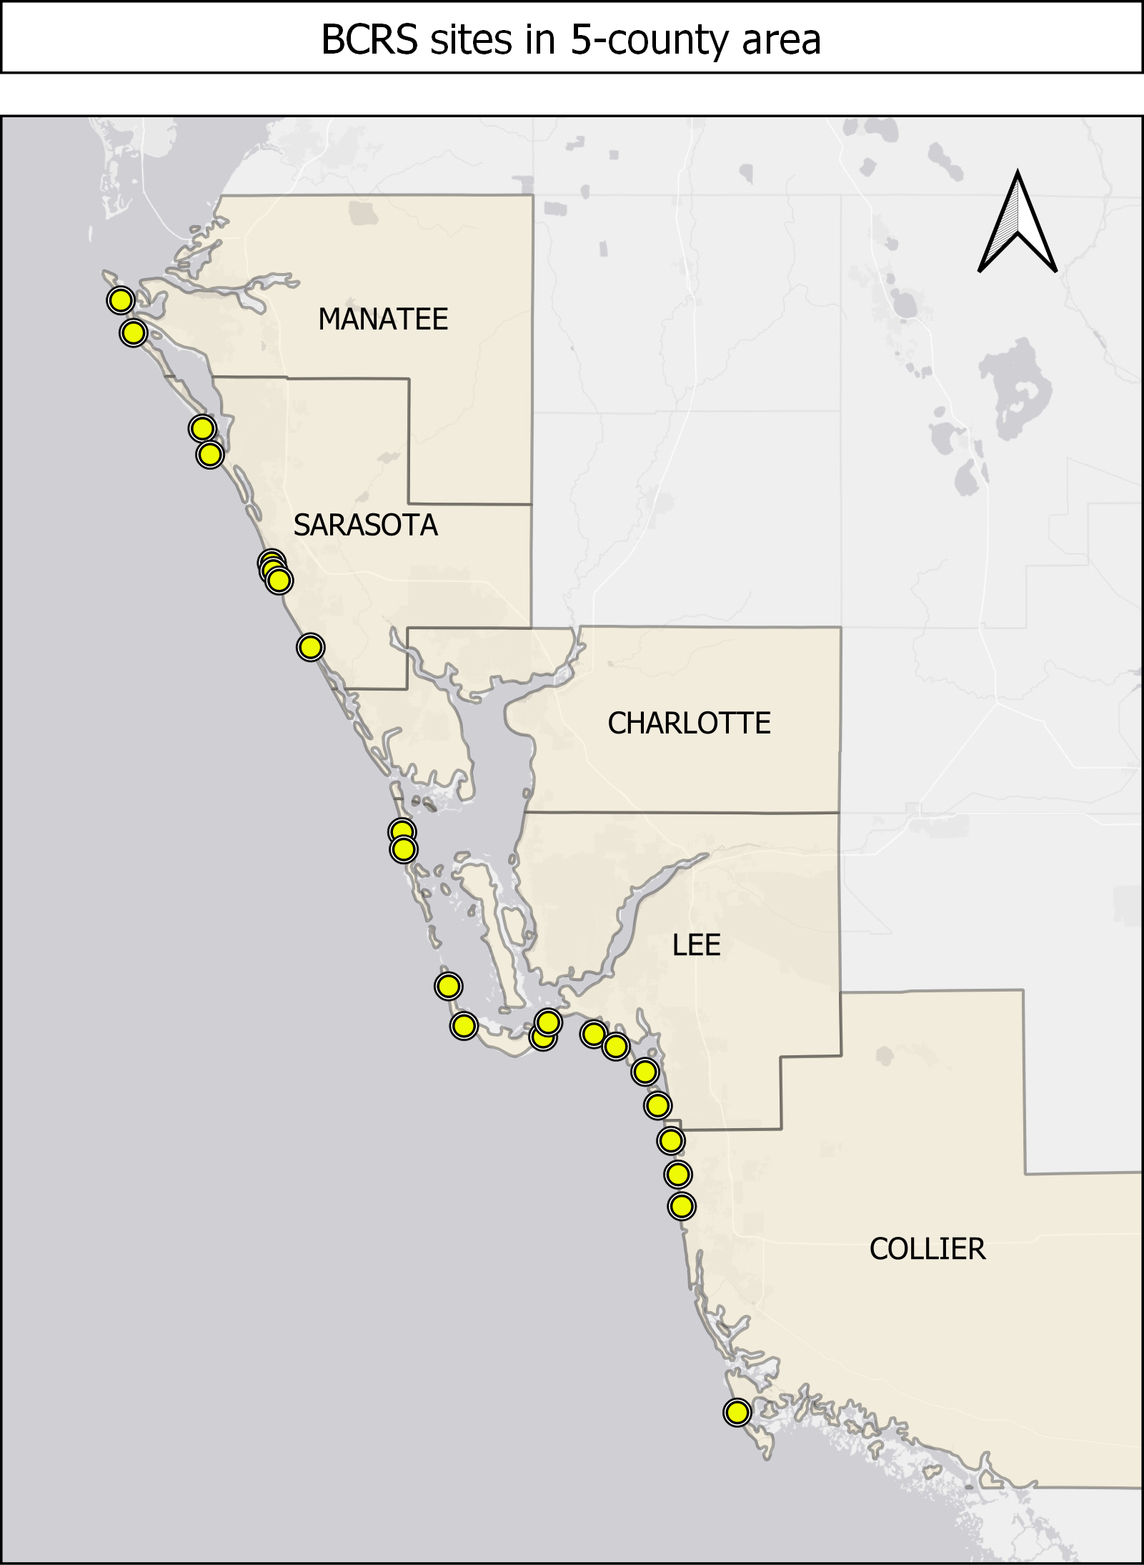  
 *basemap source: Esri gray (light)*

Q22   
Among other information, the BCRS gives reported**irritation levels due to RT conditions** for a given beach. These levels are based on reports from trained beach sentinels, such as lifeguards,   
 based on self-experienced coughing and sneezing, or observed coughing and sneezing nearby. The different levels reported in the BCRS are defined as follows:

|  |  |
| --- | --- |
| Irritation level | observed symptoms |
| None | No coughing observed due to airborne toxins |
| Slight | A few coughs / sneezes heard about every 30 seconds |
| Moderate | A cough / sneeze heard every 5 seconds |
| High | Coughing / sneezing heard almost continuously |

This information is **updated on average twice / day**, usually around 10 am and 3 pm, or when conditions change dramatically.    
   
 The BCRS system is designed to indicate to beach visitors which beach may be more preferable to visit at a given time.

|  |  |
| --- | --- |
| Page Break |  |

Q23   
Florida Fish & Wildlife Conservation Commission (FWC) Red Tide Current Status (RTCS) web site   
  
 This web site can be accessed at <https://myfwc.com/research/redtide/statewide/>.   
   
 It summarizes RT concentrations observed over the **past week** based on **water samples** at different locations andfor different regions, including Southwest Florida.   
   
 The web site has a link to a **detailed report** with RT concentrations for a given day and sample site. The report also lists **telephone "hot lines"** to obtain the latest status report on RT conditions throughout the state.  
   
 The FWC web site also links to a **map of Southwest Florida** that shows the sampling points and color-coded RT concentration levels. An example of such a map was given earlier in this survey for August, 2018 conditions.   
    
The FWC report categorizes RT concentrations as follows:   
 

|  |  |  |
| --- | --- | --- |
| Description | K. brevis cell counts | Possible effects |
| not present / background | 0 - 1,000 cells/liter | no effects anticipated |
| very low | >1,000 - 10,000 cells/liter | possible respiratory irritation |
| low | >10,000 - 100,000 cells/liter | respiratory irritation; possible fish kill |
| medium | >100,000 - 1,000,000 cells/liter | respiratory irritation; probable fish kill |
| high | > 1,000,000 cells/liter | as above, plus water discoloration |

    
    
Note that the RTCS reports RT cell concentrations **in the water**, not in the air. However, under onshore wind conditions it can be expected that there will be airborne toxins in nearby beach and shore areas as well if cell concentrations in the water are high.

|  |  |
| --- | --- |
| Page Break |  |

Q24 National Oceanic and Atmospheric Administration (NOAA) Gulf Of Mexico Harmful Algal Bloom Forecast (HABF)   
    
NOAA issues weekly (twice-weekly during a bloom) forecasts for red tide blooms in the Gulf of Mexico on the following web site: <https://tidesandcurrents.noaa.gov/hab/gomx.html>.  
   
 The web site provides a 3-4 day forecast of **potential respiratory irritation** for four target regions, including Southwest Florida. This forecast is described in a **brief report** and through a **color-coded map.**  
   
 The following web link gives a recent example for the forecast from Nov. 25 - 28, 2019:  
 [https://tidesandcurrents.noaa.gov/hab/hab_bulletin.html](https://tidesandcurrents.noaa.gov/hab/hab_bulletin.html?region=gomx&amp;file=HAB20191125_2019046_SFL.pdf)   
[region=gomx&file=HAB20191125_2019046_SFL.pdf](https://tidesandcurrents.noaa.gov/hab/hab_bulletin.html?region=gomx&amp;file=HAB20191125_2019046_SFL.pdf)   
  
 NOAA categorizes **respiratory irritation levels** as follows:

|  |  |
| --- | --- |
| Irritation level | affected population |
| None | None |
| Very low | people with chronic respiratory conditions |
| Low | in addition: people that sensitive to red tide |
| Moderate | in addition: general public (mild symptoms) |
| high | general public (intense symptoms) |

|  |  |
| --- | --- |
| Page Break |  |

|  |
| --- |
|  |

Q25 **How familiar are you** **and your household** **with these three RT information sources?** Please check the category the best applies to you and your household for each system:

|  |  |  |  |  |  |  |
| --- | --- | --- | --- | --- | --- | --- |
|  | never heard of it (1) | heard of it, but never used it (2) | use it occasionally (1-4 days/month) (3) | use it quite often (5-10 days / month) (4) | use it frequently (11-20 days/ month) (5) | use it almost daily (21-30 days/month) (6) |
| Mote's Beach Conditions Reporting System (1) |  |  |  |  |  |  |
| FWC's Red Tide Current Status web site (2) |  |  |  |  |  |  |
| NOAA's Gulf of Mexico Harmful Algal Bloom Forecast (3) |  |  |  |  |  |  |

|  |  |
| --- | --- |
| Page Break |  |

Q26 Summary of existing RT reporting / forecasting system  
   
 The important features of the existing three RT conditions sources can be summarized in terms of the **time frame** they cover, their **spatial resolution** (for which specific locations the information is given), and their **updating frequency** (how often information is "refreshed" with new data):  
   
 BCRS (by Mote) **TIME FRAME:**Current conditions only, no forecast **SPATIAL RESOLUTION**: 22 specific beach locations in the SFGC area **UPDATING:** about twice / day   
 RTCS (by FWC) **TIME FRAME:** past week **SPATIAL**RESOLUTION: 20-30 specific sampling points along the coast (largely overlapping with BCRS locations) **UPDATING:** once / week (status report), daily (maps)   
 HABF (by NOAA) **TIME FRAME:** 3-4 days ahead **SPATIAL RESOLUTION**: 22 broad regions only (examples: "North Sarasota County Gulf Coast," "Southern Charlotte County Bay Regions," etc.), no specific point locations **UPDATING:** generally once per week; twice per week during a bloom

|  |  |
| --- | --- |
| Page Break |  |

Q27   
The new proposed forecasting system  
     
In comparison, the new forecasting system we would like you to consider will have the following characteristics:   
  **TIME FRAME**: 24 hours ahead, by the hour **SPATIAL RESOLUTION**: specific forecast for **each square mile within the coverage area** (about 1,300 locations in 6-mile band, about 2,600 locations in 12-mile band) **UPDATING**: hourly   
  
 In a nutshell, the proposed system will have **much higher spatial resolution** and **much more frequent updating** than any of the existing sources. It will also **reach further inland** than any of the existing systems.   
    
As has been found repeatedly over time, Florida red tide concentrations are **patchy in nature** over space and time, which means that **conditions can change quickly** even across **neighboring locations** and**over a short period of time.**  
   
 Therefore, high **spatial resolution** and **frequent updating** play a key role in giving residents accurate information on current and near-future Florida red tide conditions.

|  |  |
| --- | --- |
| Page Break |  |

Q28   
An example of the new proposed forecasting system   
  
 The new proposed system is planned to be accessed via the **internet** or a **smart phone app**. It would allow you to see RT air conditions for any area along the coast for the current hour, and for the next 24 hours, by the hour.  
   
     
The irritation levels will be given in four levels, with the same labels as used for Mote's BCRS:   
 

|  |  |  |
| --- | --- | --- |
| **irritation level** | **color code** | **affected population** |
| none | white | none |
| low | yellow | people with chronic respiratory problems; people sensitive to red tide |
| moderate | orange | general public (mild/moderate symptoms) |
| high | red | general public (intense/sever symptoms) |

|  |  |
| --- | --- |
| Page Break |  |

Q29   
An example of the new proposed forecasting system   
    
For example, if you access the system at 6 am in the morning, you would be able to see forecasted irritation levels for each hour until the next day at 6 am. If you were to return to the system at 12 pm (noon), you could see the forecast until noon the next day, and so on.  
   
 The following example shows **hypothetical conditions for Sarasota** for 9 AM, 12 PM (noon), 3 PM, and 6 PM in the evening. You would be able to see all of these at 6 AM in the morning. Of course, the actual system would allow you to access 24 such images, one for each hour between 6 an NOW and 6 am the next day.  
   
 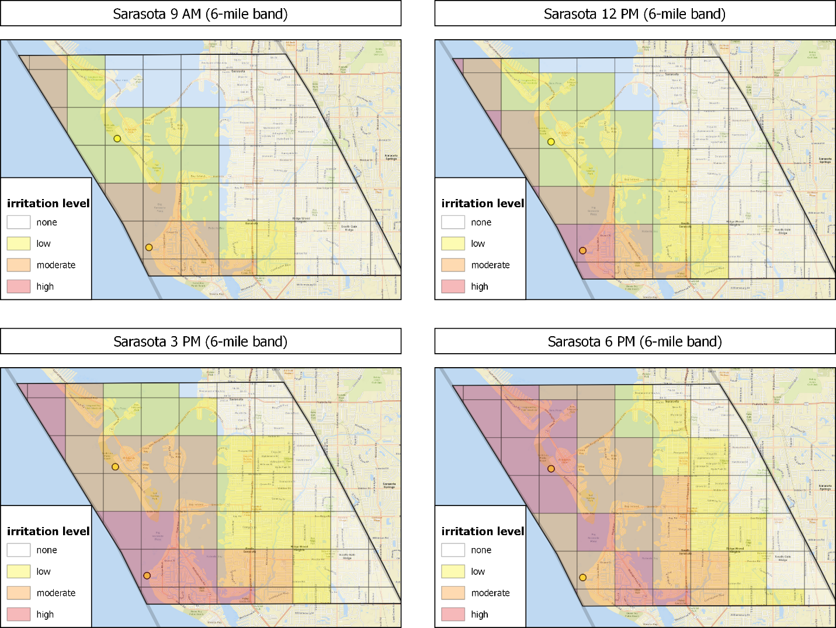  
 basemap: Esri Standard

|  |  |
| --- | --- |
| Page Break |  |

Q30   
An example of the new proposed forecasting system   
 The system would then allow you to **click on any of the squares** to take a closer look at the forecasted irritation level **for that square** over the next 24 hours.  
   
 To continue with our example, suppose you want to know the forecast for the **St. Armands / Lido Key neighborhood** within the Sarasota area.   
   
 When you click on the corresponding square at **6 AM**, you would see the following information:   
  
 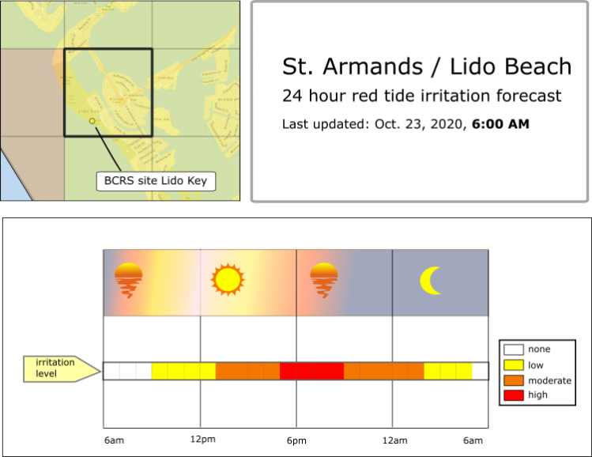

|  |  |
| --- | --- |
| Page Break |  |

Q31   
An example of the new proposed forecasting system     
If you were to click on the same square six hours later, at **12 PM (noon)**, the forecast would have advanced to 12 PM the following day:  
 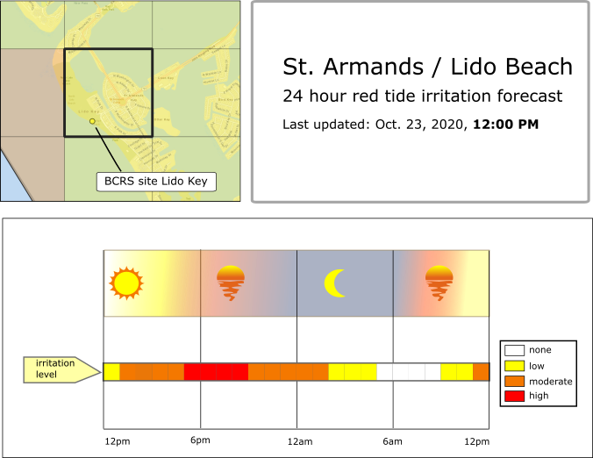

|  |  |
| --- | --- |
| Page Break |  |

Q32   
Your forecasting choices   
  
 Implementing this forecast will require substantial **human and technological resources**. The more area is covered by the forecast, and the more accurate it is designed to be, the more resources and **funding** will be needed.  
   
 To get this right, we will ask you about your preferences for two key forecasting features:   
  **spatial coverage** and

**forecasting accuracy**

|  |  |
| --- | --- |
| Page Break |  |

Q33   
Your forecasting choices: Spatial coverage   
  
 In terms of **spatial coverage**, you will get to choose between two options:   
  **6-mile band** (about 1,300 forecasting squares) **12 mile band** (about 2,600 forecasting squares)   
  
 An overview of the two options is shown below for the 5-county coastal area:  
   
 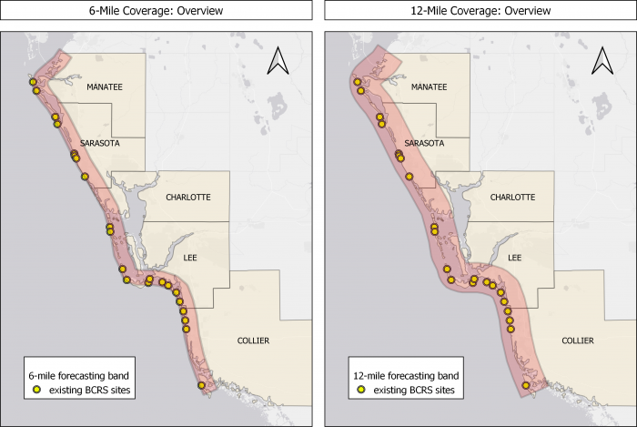  
 basemap source: Esri gray (light)   
    
As you can see, both options cover most of the beaches and adjacent neighborhoods along the coast, including all 22 of Mote's BCRS sites (yellow dots). However, the 12-mile band reaches further out into the Gulf, and also captures more inland terrain.

|  |  |
| --- | --- |
| Page Break |  |

Q34   
Your forecasting choices: Spatial coverage   
  
 Here is a closer look at the difference between the 6-mile and 12-mile band spatial coverage for some of the population hubs along the coast:   
  
 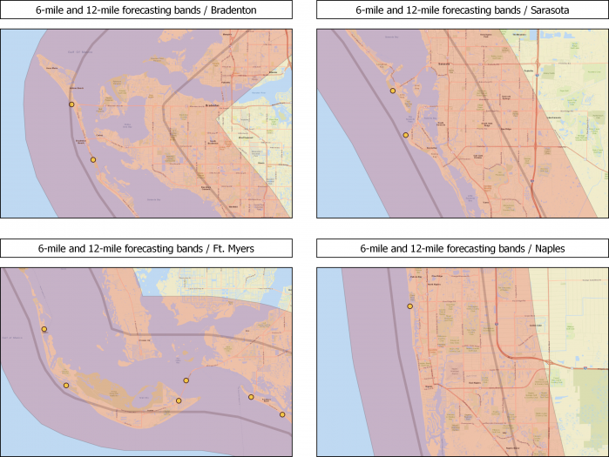  
basemap source: Esri Standard

|  |  |
| --- | --- |
| Page Break |  |

Q35   
Your forecasting choices: Forecast Accuracy   
  
 You will see different forecast accuracy level for the **first 12 hours** and the **second 12 hours** in a given 24-hour period.  
   
 For each, accuracy can take **one of three levels**:  
   fully accurate (0 hourly errors within 12 hours) 75% accurate (3 hourly errors within 12 hours) 50% accurate (6 hourly errors within 12 hours)  
     
Please assume that if there is an error for a specific hour of the forecast, it can go in **either direction**, but it will be **no more than one irritation category off the truth**. Thus, the possible errors are as follows:

|  |  |
| --- | --- |
| **true irritation level** | **possible errors:** |
| none (white) | low (yellow) |
| low (yellow) | none (white), moderate (orange) |
| moderate (orange) | low (yellow), high (red) |
| high (red) | moderate (orange) |

 

|  |  |
| --- | --- |
| Page Break |  |

Q36   
Your forecasting choices: Forecast Accuracy   
  
 Here is an example of the different accuracy levels for the **first 12 hours** of a given forecast:  
   
 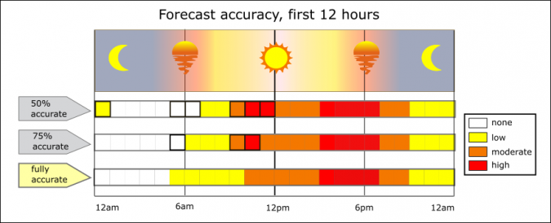  
  
  

|  |  |
| --- | --- |
| Page Break |  |

Q37   
Your forecasting choices: Forecast Accuracy   
  
 Here is an example of the different accuracy levels for the **second 12 hours** of a given forecast:  
   
 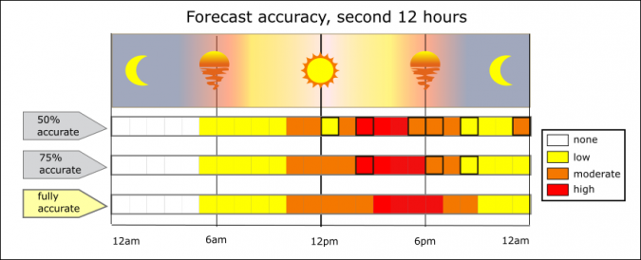  
  
  

|  |  |
| --- | --- |
| Page Break |  |

|  |
| --- |
|  |

Q38 When considering these forecasting attributes, **how important to you** is each of the following? Please check one box for each:

|  |  |  |  |  |  |
| --- | --- | --- | --- | --- | --- |
|  | Extremely important (1) | Very important (2) | Moderately important (3) | Slightly important (4) | Not at all important (5) |
| The **spatial coverage** **band** of the forecast should be as wide as possible. (1) |  |  |  |  |  |
| For each square, the forecast should be **perfectly accurate** for every single hour for the **first 12 hours**. (2) |  |  |  |  |  |
| For each square, the forecast should be **perfectly accurate** for every single hour for the **second 12 hours**. (3) |  |  |  |  |  |

|  |  |
| --- | --- |
| Page Break |  |

Q39   
Alternative Forecasting Systems   
 In the following section will each ask you to consider **two versions of the new forecasting system** and **vote for the one you prefer**.   
   
 The two systems will differ based on **spatial coverage**, **accuracy**, and **annual cost to your household**. You will also have the choice of sticking with the current situation (no new forecasting system, existing sources of RT information only) at no additional cost.  
   
 Your responses will help public officials and nonprofit organizations understand the **tradeoffs that are most acceptable to you**, and the type of forecasting system you would support or oppose in an actual public vote.  
   
 For each choice triplet (two versions of the new system, plus the existing situation) you will get to choose you preferred option. We will ask you to do this four times for four different choice triplets.   
    
Here is an **example** of such a choice triplet (you do NOT need to vote for this one):   
    
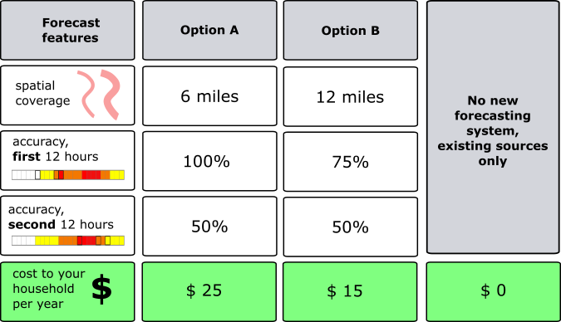

* **I would vote for** **option A** (1)
* **I would vote for** **option B** (2)
* **I would vote for** **existing sources only** (3)

Q40   
How would the new forecasting system be funded and implemented?   
    
**Who would pay for the new system?**  
   
 The new forecasting system would be covered through **new local taxes and fees** that would be applied across the 5-county region. Your household would pay a share of these new costs. These payments would continue indefinitely as long as you remain a resident of the 5-county area (Manatee, Sarasota, Lee, Charlotte, Collier).   
    
  
 **Who would have access to the new system?**  
   
 Your responses will help public officials decide on the implementation of a new forecasting system. If it were to be implemented, it would be **accessible to the public at large**, in form of a public web site and a smart phone app. That means everybody with internet access can go to the web site or app and learn about the 24-hour ahead RT conditions for their neighborhoods (squares) of interest.

|  |  |
| --- | --- |
| Page Break |  |

|  |
| --- |
|  |

Q41   
How would you vote?   
    
There are valid reasons you might vote for a specific forecasting system or the existing information sources.   
    
For example, some people may vote for a system with broader (12-mile) coverage because it covers areas beyond the 6-mile band that are important to them (e.g. where they live, where their children go to school, where they like to engage in outdoor activities, etc.).  
   
 Some people may care a lot about the hour-by-hour accuracy of a forecast since they are very sensitive to red tide air toxins, and cannot risk being exposed even if the forecast is only slightly "off."  Others might be OK with slight errors here and there, as long as the hourly reports are not too far off the mark.  
  
  
Some locals may be more interested in the accuracy of the first 12-hours of a forecast, since that's the time period over which they plan their activities in most cases. In contrast, others may care more about the second 12-hours of a forecast as they generally like to plan and schedule their activities well ahead of time.  
   
 Yet other households may opt to stick with the current information sources and not vote for a new forecasting system, perhaps because the rarely spend time outdoors, are flexible to make outdoors decisions based on current conditions, or prefer to spend their money on something else.   
    
Whatever **your** reasons, your vote is legitimate, regardless which choice you make.   
    
**Acknowledgement:** By clicking the statement below I acknowledge that:

* I understand that in the following choice options I can vote for either new forecasting system A or B, or for the existing sources of information on Florida red tide air quality. I also understand that I should choose the option that is **best for my household.** (1)

|  |  |
| --- | --- |
| Page Break |  |

Q42   
As you vote, please remember these important details   
  Please review each question carefully. The results of this survey will be shared with public officials to help them decide if such a new forecasting system should be implemented for the 5-county area, and which features it should have. Think about your vote just like you would if you voted in an actual binding public referendum.  
   Assume that these are the only forecasting systems considered at the current time, and that all funds are legally guaranteed to be spent on the preferred system, should it be implemented.​  
   Assume that if the majority of households support the new forecasting system it will be implemented, and that all households will share the costs.    
   Assume that implementing the new forecast would not diminish or interfere with other programs currently underway to stop the detrimental effects of red tide on south-western Florida.  
   It is important that you make each of the forecasting choices in the next section like you would if you were actually facing these exact choices in reality.   
   Therefore, please consider carefully how you would vote. Your household's contribution to the new forecasting system would **reduce your available budget** for other private expenses or possible future contributions to other public priorities such as schools, other public health issues, transportation, public safety or other environmental concerns.

|  |  |
| --- | --- |
| Page Break |  |

Q43   
As you vote, please remember these important details

* There are 4 voting questions, each on a different page. Do not add up or compare options from different pages. Only choose among options on that page **as if they were the only options available.**
* The costs of a given forecasting option depend on both spatial coverage and accuracy. Therefore, 12-mile band forecasts will not always be more expensive to implement than 6-mile forecasts, and a 100% accurate forecast for the first 12 hours will not always cost more than a 75% or 50% accurate version, and so on.

End of Block: Starting Block

Start of Block: Choice Block 1.1

|  |  |
| --- | --- |
|  |  |

Q44   
Voting question 1:   
 Given a choice between the following three options, how would you vote?   
  
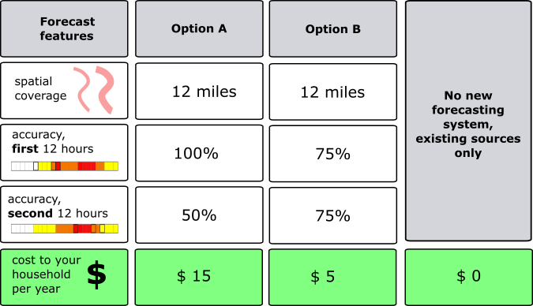

* **I would vote for** **option A** (1)
* **I would vote for** **option B** (2)
* **I would vote for** **existing sources only** (3)

|  |  |
| --- | --- |
| Page Break |  |

|  |
| --- |
|  |

Q45   
Voting question 2:   
 Now consider instead the following three options.  If these were the only options available, how would you vote in this case?   
    
 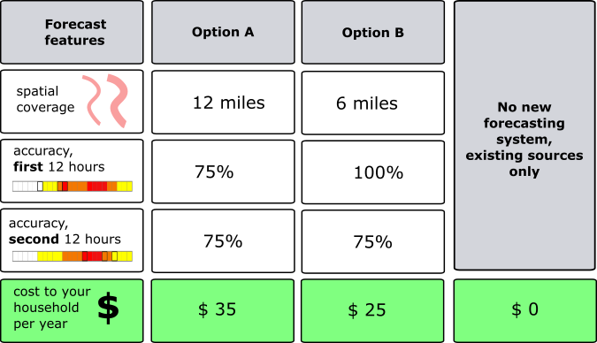

* **I would vote for** **option A** (1)
* **I would vote for** **option B** (2)
* **I would vote for** **existing sources only** (3)

|  |  |
| --- | --- |
| Page Break |  |

|  |
| --- |
|  |

Q46   
Voting question 3:   
 Here is yet another set of possible forecasting system options.  If these were the only options available how would you vote in this case?   
    
 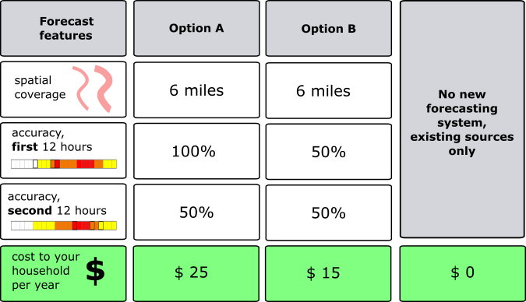

* **I would vote for** **option A** (1)
* **I would vote for** **option B** (2)
* **I would vote for** **existing sources only** (3)

|  |  |
| --- | --- |
| Page Break |  |

|  |
| --- |
|  |

Q47   
Voting question 4:   
 Here is the last set of possible forecasting system options for you to consider.  If these were the only options available, how would you vote in this case?   
    
 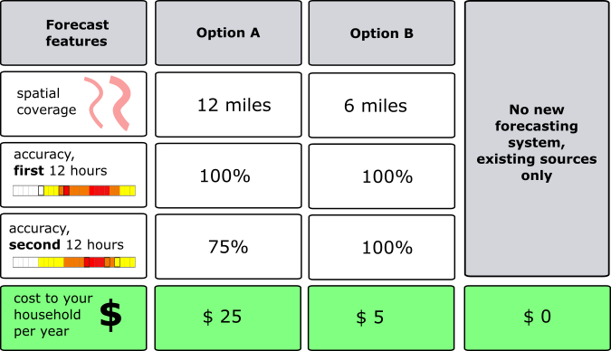

* **I would vote for** **option A** (1)
* **I would vote for** **option B** (2)
* **I would vote for** **existing sources only** (3)

|  |  |
| --- | --- |
| Page Break |  |

Start of Block: Block 23

Q48 **Which of the following reasons best explain why you voted the way you did? (Please check all that apply).**

* Any new forecasting service should be provided by local/state governments at no cost to local residents. (1)
* The new systems proposed in the questions were not worth the cost to me and my household. (2)
* My household is already paying plenty of taxes and fees - these should be enough to cover the new forecasting system. (3)
* My household simply can't afford to pay for a new forecasting system at this time. (4)
* I / my household rarely spend time outside. (5)
* I / my household can be very flexible in making outdoor choices - information on current conditions for local beaches is sufficient. (6)
* Florda red tide toxins don't bother me / my household much. (7)
* The forecasting system would not cover areas that are important to me. (8)
* I am worried that voting for a better forecasting system will slow down other efforts to mitigate Florida red tide. (9)
* I would not use the new system often enough to warrant the cost. (10)
* I do not believe such a new forecasting system is scientifically feasible. (11)
* other (please explain) (12) ________________________________________________

|  |
| --- |
|  |

Q49 **Which of the following reasons best explain why you voted for one or more versions of the new forecasting system? (Please check all that apply).**

* The new system would reduce the risk of exposure to Florida red tide air toxins to me / my household. (1)
* The new system would allow me / my household to spend more time outdoors. (2)
* The new system would allow me / my household to better plan out daily activities. (3)
* The new system would allow me / my household to decide WHEN to engage in outdoor activities. (4)
* The new system would allow me / my household to decide WHERE to engage in outdoor activities. (5)

End of Block: Block 23

Start of Block: Ending Block

|  |
| --- |
|  |

Q164 **Please indicate how strongly you agree or disagree with the following statements (check one box for each).**

|  |  |  |  |  |  |  |  |
| --- | --- | --- | --- | --- | --- | --- | --- |
|  | strongly disagree (1) | Disagree (2) | Somewhat disagree (3) | Neither agree nor disagree (4) | Somewhat agree (5) | Agree (6) | Strongly agree (7) |
| This survey provided enough information for me to make informed choices. (1) |  |  |  |  |  |  |  |
| I feel confident about my forecasting system votes. (2) |  |  |  |  |  |  |  |
| The information in the survey was easy to understand. (3) |  |  |  |  |  |  |  |
| The information in the survey was fair and balanced. (4) |  |  |  |  |  |  |  |
| The choice questions were easy to answer. (5) |  |  |  |  |  |  |  |
| I would vote in the same way on a public vote or referendum. (6) |  |  |  |  |  |  |  |
| I voted as if my household would actually face the costs shown in the question. (7) |  |  |  |  |  |  |  |
| The survey pushed me to vote for a new forecasting system. (8) |  |  |  |  |  |  |  |
| The survey pushed me to vote against the new forecasting system. (9) |  |  |  |  |  |  |  |
| The description of existing red tide information sources was sufficient to allow me to make informed choices. (10) |  |  |  |  |  |  |  |
| The survey let me make up my own mind between the offered choices. (11) |  |  |  |  |  |  |  |

Q165   
Questions about you and your household   
 In this final section we would like to ask a few questions about you and your household. Please remember that your answers are confidential and will not be linked to your name in any way. This information will help us to ensure that all population groups are fairly represented.

|  |  |
| --- | --- |
| Page Break |  |

Q166 What is your gender?

* Male (1)
* Female (2)
* other gender identification (3) ________________________________________________

|  |  |
| --- | --- |
| Page Break |  |

Q167 What is your age?

________________________________________________________________

|  |  |
| --- | --- |
| Page Break |  |

Q168 How many **family members** live in your home including yourself (number of people)?

________________________________________________________________

|  |  |
| --- | --- |
| Page Break |  |

Q169 How many **family members** **under the age of 7** live in your home (number of people)?

________________________________________________________________

|  |  |
| --- | --- |
| Page Break |  |

Q170 How many **family members** **age 7-18** live in your home (number of people)?

________________________________________________________________

Q171 How many **family members** **with pre-existing respiratory conditions (such as asthma)**live in your home (number of people)?

________________________________________________________________

|  |  |
| --- | --- |
| Page Break |  |

Q172 How many years have you lived at your **current address**? (Please round to the nearest number of years)

________________________________________________________________

|  |  |
| --- | --- |
| Page Break |  |

Q173 How many **consecutive years** have you lived in your **current county**? (Please round to the nearest number of years)

________________________________________________________________

|  |  |
| --- | --- |
| Page Break |  |

Q174 How many **consecutive years** have you lived in the **5-county area** (Manatee, Sarasota, Lee, Charlotte, or Collier county)? (Please round to the nearest number of years)

________________________________________________________________

|  |  |
| --- | --- |
| Page Break |  |

Q175 In which city / town do you currently live?

________________________________________________________________

|  |  |
| --- | --- |
| Page Break |  |

Q176 In 2019, what was your total **pre-tax household income**?

* under $15,000 (1)
* $15,000 - $24,999 (2)
* $25,000 - $34,999 (3)
* $35,000 - $49,999 (4)
* $50,000 - $74,999 (5)
* $75,000 - $99,999 (6)
* $100,000 - $124,999 (7)
* $125,000 - $149,999 (8)
* $150,000 - $174,999 (9)
* $175,000 - $199,999 (10)
* $200,00 - $249,999 (11)
* $250,000 - $299,999 (12)
* $300,000 - $499,999 (13)
* $500,000 and over (14)

|  |  |
| --- | --- |
| Page Break |  |

|  |
| --- |
|  |

Q177 What is the highest degree or level of education you have completed?

* Elementary school only (1)
* Some high school but no high school diploma or General Education Diploma (GED) (2)
* High school diploma (3)
* GED or other high school equivalent (4)
* Some college (5)
* Associate's degree or other two-year college degree (6)
* Bachelor's degree or other four-year college degree (7)
* Master's degree, professional degree, or doctoral degree (for example: MA, MS, MSW, MD, DDS, JD, PhD, EdD) (8)

|  |  |
| --- | --- |
| Page Break |  |

Q178   
Additional comments (we'd love to hear any additional thoughts you might have on this survey or topics discussed in this survey)

________________________________________________________________

________________________________________________________________

________________________________________________________________

________________________________________________________________

________________________________________________________________

End of Block: Ending Block